

DEPARTMENT OF COMPUTER SCIENCE AND ENGINEERING

23CSE304 Embedded Systems Laboratory

Activity Sheet #1

Activity Name: GPIO LED Interfacing

Assessment Rubrics:

Name of Student: |  | Agneay B Nair
Registration No.: |  | CH.SC.U4CSE24102
Activity Date: |  | 18-08-2026
Submission Date: |  | 18-08-2026
Component | Maximum Marks |  | Marks Allotted
Program | 3
Output | 4
Viva | 2
Timely Submission | 1
Total | 10

Faculty In-charge

Write an embedded C program for ARM architecture to interface an LED. Debug and verify the program using IDE on a development computer system.

#include<stdio.h>
#include<LPC213x.h>

void delay(int n){
int i;
for(i = 0;i<n*10000;i++);
}

int main(){
PINSEL0 = 0x00000000;
IODIR0 |= (1<<8);
while(1){
IOSET0 = (1<<8);
delay(10);
IOCLR0 = (1<<8);
delay(10);
}
}

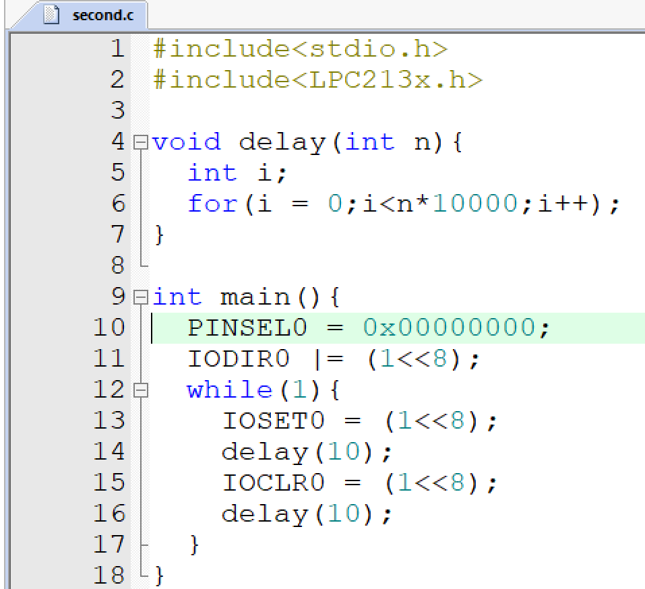

OUTPUT:
